Algebra 1: Unit 14, Lesson 4

- A librarian is collecting data to determine if there is an association between grade and book genre preference. The data collected by the librarian is shown in the table.
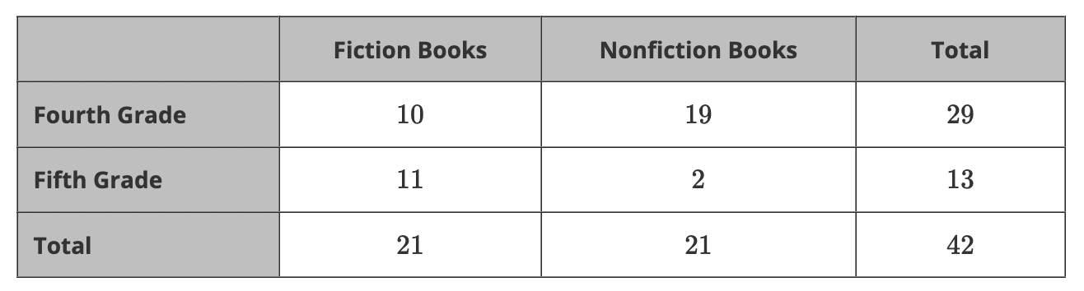

What fraction of the total students are in fourth grade and prefer nonfiction books?

$$\frac{19}{42}$$

- Emilee surveyed her neighbors to determine if there was an association between age and holiday preference. The results are shown in the table and segmented bar graph.
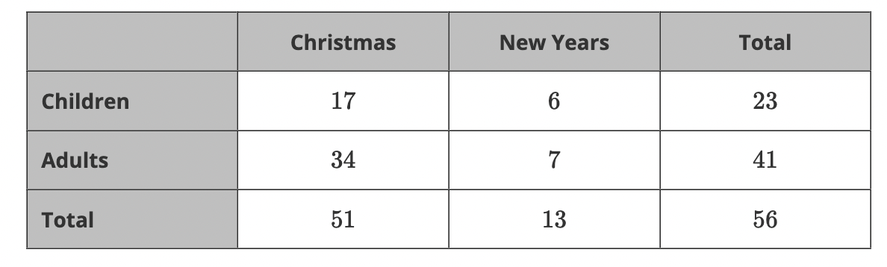
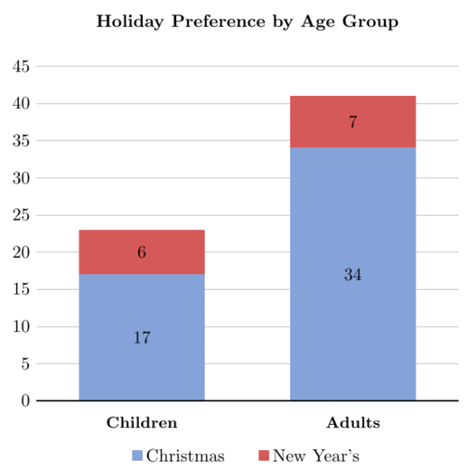
About what fraction labeled “Children” is red?
$$\frac{1}{4}$$

- Jose would like to know if there is any association between playing a sport and being in a school club. The data he collected is shown in the table and segmented bar graph
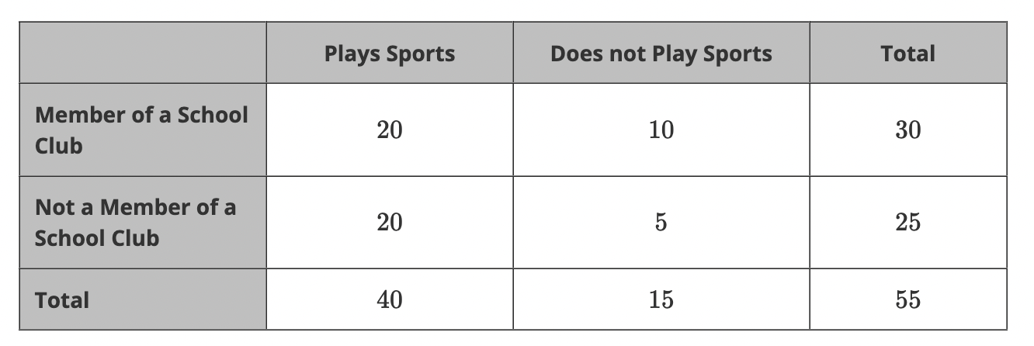
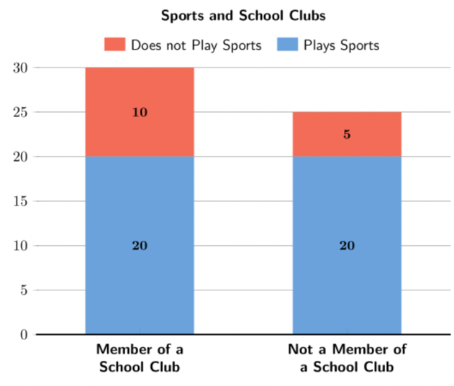
Is the proportion of students who do not play sports the same or not the same for both members and nonmembers of the school club?
Not the same

